JAC444 - Lecture 9

Java Collections

Segment 1- Basics

**Jordan Anastasiade – Java Programming Language Course**

**Collections**

**In this lesson you will be learning about:**

* Java Collections Framework
* The Collection Interface
* Set, List, Map Interfaces
* General Purpose Implementations
* Algorithms
* Compatibility with Vector, Hashtable
* Streams

**Collection Basics**

**In this first segment you will be learning about:**

* Java Collections Framework
* The Collections Interface
* The Collections Implementation

Reference:

http://docs.oracle.com/javase/tutorial/collections/index.html

**The Collection**

A

*collection*

represents a group of objects, known as its elements.

**Collection**

Elements

Object

Collection Framework

Container

Object

I

nterfaces

Implementations

Algorithms

Object

Object

Object

Object

Object

**Using Collections**

The collection classes and interfaces are defined in the package **java.util**

The interface **Collection<E>** from **java.util** isthe root interface in the collection hierarchy

*Important note:*

There is also **java.util.Collections** but this is a class that consists exclusively of static methods that operate on or return collections

**Collections Hierarchy**

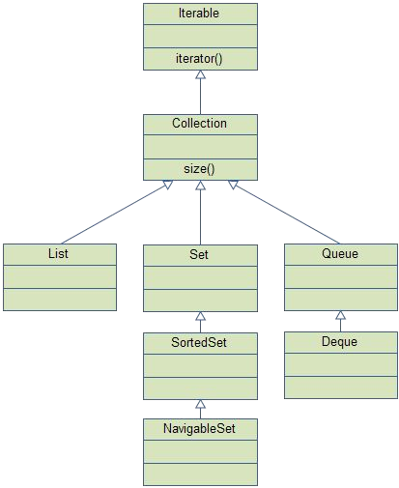

Iterable Documentation

T

he root interface in the collection hierarchy

**The Collection<E> Interface**

|  |  |
| --- | --- |
| **public interface Collection<E> {**  **// Group 1 int size(); boolean isEmpty();**  **boolean contains(Object element); boolean add(Object element); // Optional boolean remove(Object element); // Optional Iterator iterator();**  **// Group 2**  **boolean containsAll(Collection c); boolean addAll(Collection c); // Optional boolean removeAll(Collection c); // Optional boolean retainAll(Collection c); // Optional void clear(); // Optional**  **// Group 3**  **Object[] toArray();**  **Object[] toArray(Object a[]);**  **}** | **1**  Basic  Operations   1. Bulk   Operations   1. Array   Operations |

**Iterator<E> Interface**

**public interface Iterator<E> { boolean hasNext();**

**E next();**

**default void remove(); }**

**E next()**

1. Returns the current element (initially the first element)
2. Steps to the next element and makes it the current element.

**Iterator Interface**

The **Iterator** interface allows to obtain the collection's elements

Example of filtering a collection using the **Iterator** interface:

**public void filter(Collection c) { for ( Iterator i = c.iterator(); i.hasNext();)**

**if ( !cond(i.next()) )**

**i.remove();**

**}**

**Core Collection Interfaces**

Collection

Set

List

Queue

SortedSet

Map

SortedMap